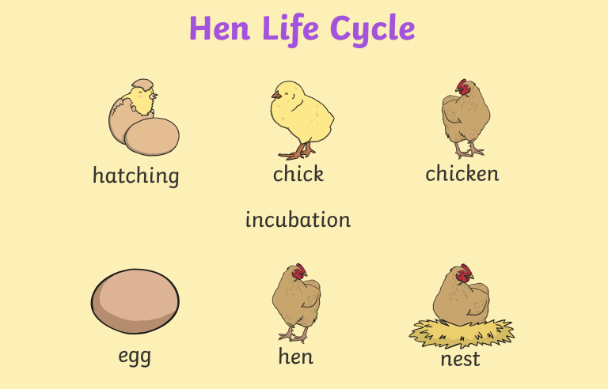

The Life Cycle of a

Chicken

4

3

2

1